Gerardo Herrera Gonzalez

2021SP CIDM 4390-01

Dr. Jeffry Babb

Assignment 1

Jan. 19, 2021

**Description of Primary and Secondary Actors**



**Use Case**

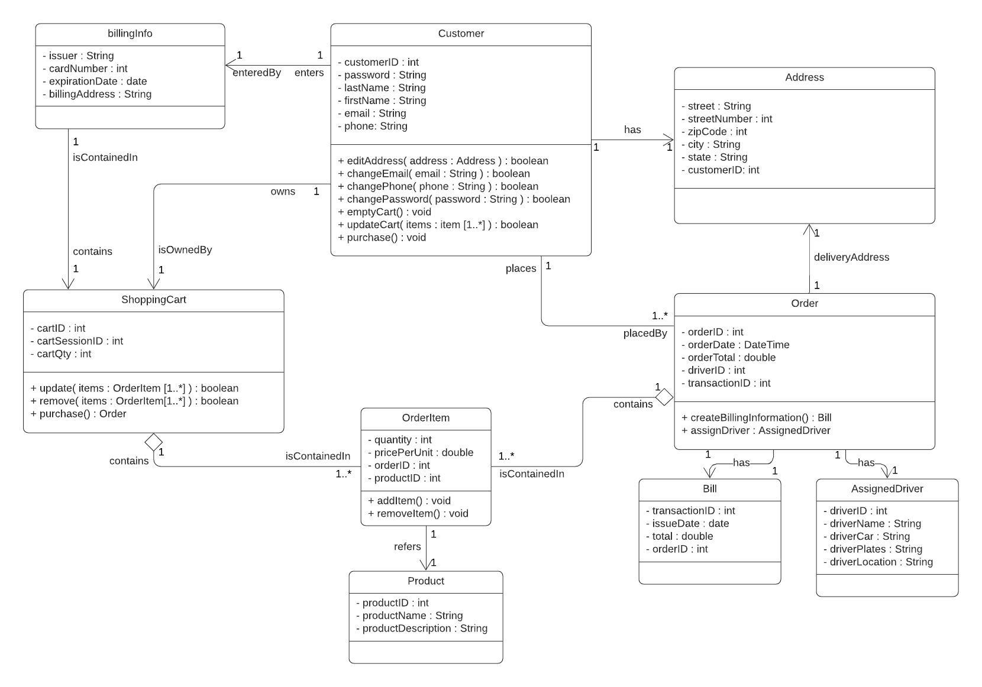**Class Diagram**

**Sequence Diagram**

**Activity Diagram**

**ERD**

